**Extracting Water Surface Elevation data from the output HEC-RAS 2D unsteady state models**

Prepared by Tianle Xu

Lyles School of Civil Engineering, Purdue University

[xu1361@purdue.edu](mailto:xu1361@purdue.edu)

1. **Objective**

The main objective of this tutorial is to programmatically extract water surface elevation (WSE) data from an output plan file and geometry file of HEC-RAS 2D unsteady state modelaccording to the coordinate of some input points within the 2D interior area of the 2D model. Students are expected to have a basic understanding of HDF file and Python.

1. **Computer Requirements**

You must have python 3 and Visual Studio Code installed on your computer.

1. **Data Source**

There are two datasets required for this exercise: (i) a plan file and (ii) a geometry file in HDF format from the output of HEC-RAS 2D unsteady flow model.

The plan file and geometry file are available in the Example Projects provided by HEC-RAS. You can download it from <https://www.hec.usace.army.mil/software/hec-ras/download.aspx> in your working folder. Then the plan file called Muncie.p04 and the geometry file called Muncie.g04 can be accessed by the following path: Example Projects\2D Unsteady Flow Hydraulics\Muncie.

1. **Instructions**
2. Lunch Visual Studio Code, create a new file, and import needed libraries.

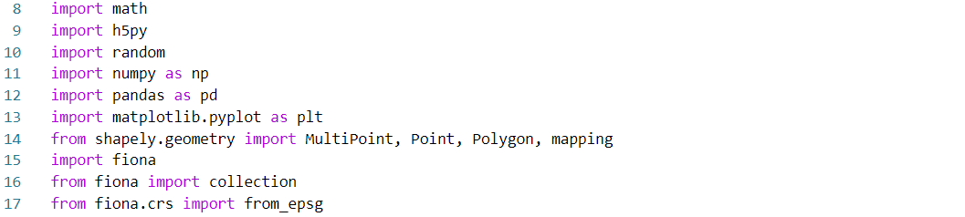

1. Provide inputs for the function. Muncie.p04 will be the input plan file and Muncie.g04 will be the input geometry file. User can define input sample points. The EPSG code for the area in this study is 102673.
2. Use h5py library to read the plan file and extract cell center coordinate data from the path: /Geometry /2D Flow Areas /2D Interior Area /Cells Center Coordinate, WSE data from the path: /Results /Unsteady /Output /Output Blocks /Base Output /Unsteady Time Series /2D Flow Areas /2D Interior Area/Water Surface, and time date stamp data from the path: /Results /Unsteady /Output /Output Blocks /Base Output /Unsteady Time Series /Time Date Stamp.

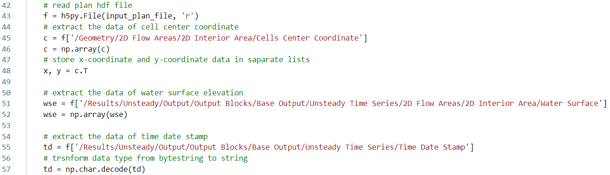

1. Use h5py library to read the geometry file and use shapely.geometry.Polygon function to create the boundary polygon of the 2D interior area based on the perimeter data accessed by the following path: /Results /Unsteady /Output /Output Blocks /Base Output /Unsteady Time Series /Time Date Stamp in the geometry file.

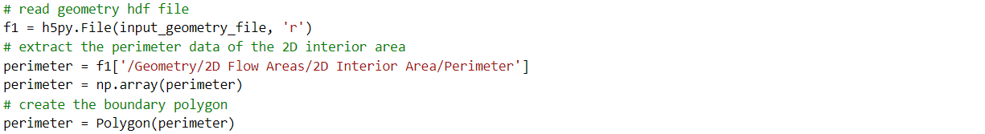

1. Check if the sample points are within the 2D interior area. We will only regard the points within the boundary polygon as valid.

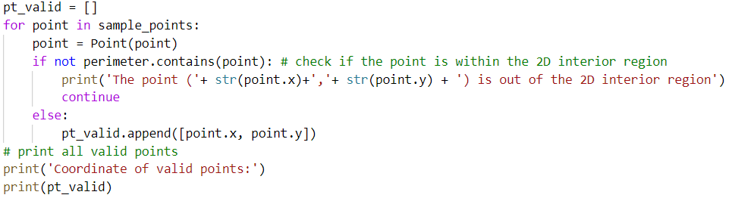

1. Create a shapefile for these valid points. Here we define another function for the creation of point shapefile, which has three parameters: coordinate is the list of coordinate values for input valid points, output_file_name is the name of output file defined by user, and coordinate_system is the EPSG code of the target location, which is 102673 in this exercise.



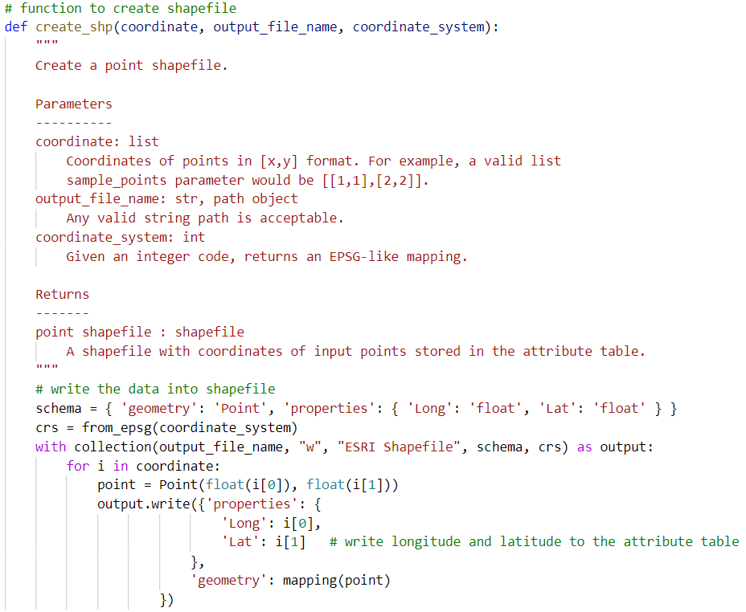

1. To get the WSE, we create IDW method to interpolate WES data. Users can define the search radius and power value.

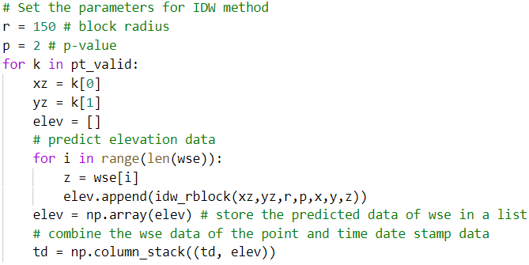

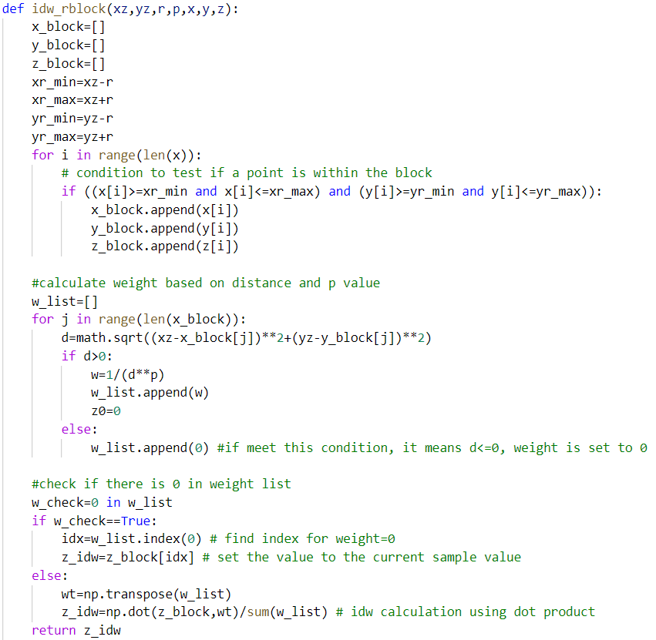

1. Save the time series data of WSE of each point as csv file.

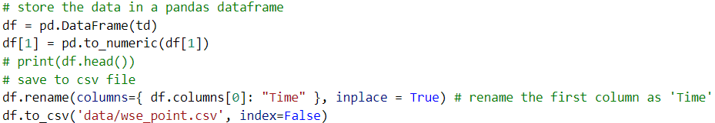

*Ok, you have completed this tutorial!*